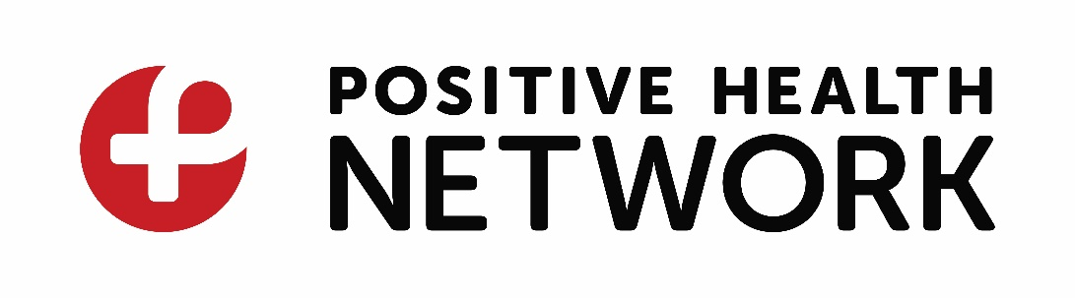

**Manager,** Priority Populations and Support **Programs and Services**

**POSITION SUMMARY:**

The Manager, Priority Populations and Support Programs and Services is responsible for the development, implementation, coordination, supervision and evaluation of direct priority population programs and support services in accordance with standards set out by Positive Health Network and our respective funders.

As a member of the Management team, the Manager, Priority Populations and Support Programs and Services participates in strategic planning, budgeting, problem solving along with initiatives that support the overall agency.

The Manager, Priority Populations and Support Programs and Services works within guidelines, policies, values, and mission of the organization and is accountable and responsible for the outcomes of the programs and services.

The Manager, Priority Populations and Support Programs and Services supervises eight direct service positions within the agency. This is a full-time management position and reports directly to the Executive Director.

**PRIMARY RESPONSIBILITIES:**

* Ensures that referrals and applications for Positive Health Network services are completed in accordance with Positive Health Network policies, standards, and guidelines.
* Makes recommendations for improvements and/or changes to Positive Health Network policies, guidelines, and standards.
* Works with the Executive Director to ensure appropriate liaison and working partnerships with other community service agencies.
* Participate in community-based networking committees as necessary.
* Liaison with other service providers in the community to ensure effective and efficient coordination and continuity of service to Positive Health Network service users and clients.
* Ensure that the Programs and Services are effective in carrying out the mandate, mission, and values of Positive Health Network.
* Develop and conduct program evaluation processes, in consultation with the Executive Director and assist in adapting programs in response to evaluation results and feedback from clients, priority populations, consumers of service, Public Health and allied community-based agencies.
* Ensure effective and efficient coordination of internal programs and services.
* Support and evaluate front line-staff and teams to build responsive programs and a healthy work environment.
* Assist in the development of program standards, procedures and guidelines ensuring consistency & quality throughout the programs.

|  |
| --- |
|  |

**KEY QUALIFICATIONS:**

* 5 years senior leadership experience within a community-based service environment or health care sector agency which focuses on populations vulnerable to HIV/AIDS.
* Must have proven, successful track record supervising frontline staff within a community-based, unionized environment.
* Demonstrated experience in project management and program development, implementation, and evaluation.
* Excellent writing and proposal development skills.
* excellent understanding of the social service networks in the Hamilton, Halton, Haldimand, Norfolk and Brant regions
* In-depth knowledge of issues facing people living with HIV/AIDS in the current environment.
* An undergraduate degree in Social Work or Social Sciences or a combination of other post-secondary education and experience.
* In-depth experience working in a community development framework.
* Proven experience working with marginalized populations with a focus on sexual health, substance use and mental health issues.
* Excellent communication skills, including conflict resolution/mediation, motivation, and mentoring.

**WHAT WE OFFER:** This is a full-time, permanent (35 hours/week) position with Positive Health Network. We offer a competitive compensation package, including comprehensive benefit package.

**Position:** Manager, Priority Populations and Support Programs and Services

**Status:** Management

**Supervisor:** Executive Director

**Supervises:** Direct program and service staff (8 direct reports)

**Salary:** $60,000- $65,000 + Benefits (starting salary commensurate with qualifications and experience)

**Location:** Hamilton, Ontario

**HOW TO APPLY:**

**Please forward your electronic resume and covering letter by email only no later than 5:00 pm on Monday, September 30th, 2024** [**recruitment@positivehealthnetwork.org**](mailto:recruitment@positivehealthnetwork.org)

*Positive Health Network values inclusion and diversity and promotes access and equity using an anti racism, anti oppression framework. Persons living with HIV are encouraged to apply.*